DDIP Documentation

Website– ScreenShots, html, code behind

Niall Ferguson

city of glagow college |

2013

Table of Contents

Lidiflu.Master 3

Screenshot 3

HTML 3

Code Behind 5

Default.aspx 7

Screenshot 7

HTML 7

Code Behind 10

Accout.aspx 13

Screenshot 13

HTML 13

Code Behind 13

Admin.aspx 15

Screenshot 15

HTML 15

Code Behind 19

CheckoutCancel.aspx 20

Screenshot 20

HTML 20

Code Behind 20

CheckoutComplete.aspx 21

Screenshot 21

HTML 21

Code Behind 21

CheckoutError.aspx 23

Screenshot 23

HTML 23

Code Behind 23

CheckoutReview.aspx 24

Screenshot 24

HTML 24

Code Behind 26

Contact.aspx 29

Screenshot 29

HTML 29

Code Behind 32

Products.aspx 34

Screenshot 34

HTML 34

Code Behind 35

Register.aspx 37

Screenshot 37

HTML 37

Code Behind 40

Shop.aspx 41

Screenshot 41

HTML 41

Code Behind 44

ShoppingCart.aspx 46

Screenshot 46

HTML 46

Code Behind 48

## Lidiflu.Master

### Screenshot

N/A

### HTML

<%@ Master Language="C#" AutoEventWireup="true" CodeFile="Lidiflu.Master.cs" Inherits="Lidiflu" %>

<!DOCTYPE html PUBLIC "-//W3C//DTD XHTML 1.0 Transitional//EN" "http://www.w3.org/TR/xhtml1/DTD/xhtml1-transitional.dtd">

<html xmlns="http://www.w3.org/1999/xhtml">

<head runat="server">

<title></title>

<asp:ContentPlaceHolder ID="head" runat="server">

</asp:ContentPlaceHolder>

<script src="http://code.jquery.com/jquery-latest.min.js" type="text/javascript"></script>

<script src="Scripts/jquery.slides.min.js" type="text/javascript"></script>

<script type="text/javascript">

$(document).ready(function () {

$('#resizer a').click(function () {

var textSize = $(this).parent().attr('class');

$('body').removeClass('small medium large').addClass(textSize);

$('p').removeClass('small medium large').addClass(textSize);

return false;

});

});

</script>

<link href="Styles/StyleSheet.css" rel="stylesheet" type="text/css" />

</head>

<body>

<form id="form1" runat="server">

<header>

<div id="topnav" class="container_12">

<div id="resizer" class="grid_2">

<ul>

<li class="small"><a href="#">A</a></li>

<li class="medium"><a href="#">A</a> </li>

<li class="large"><a href="#">A</a></li>

</ul>

</div>

<div id="shoptools" class="grid_7 prefix_3">

<ul>

<li><asp:LoginView ID="LoginView1" runat="server">

<AnonymousTemplate><a href="Register.aspx">Account</a></AnonymousTemplate>

<LoggedInTemplate><asp:Label runat="server" Text="Welcome, " Font-Size="12px"></asp:Label><asp:LoginName Font-Size="12px" ID="LoginName1" runat="server" />

<asp:LoginStatus Font-Size="12px" ForeColor="#2583B7" ID="LoginStatus1" runat="server" />

</LoggedInTemplate>

</asp:LoginView></li>

<li><asp:Label ID="lblItems" runat="server" Text=""></asp:Label></li>

<li><asp:Label ID="lblCost" runat="server" Text="£0.00"></asp:Label></li>

<li><a href="ShoppingCart.aspx">Shopping Cart</a></li>

</ul>

</div>

</div>

<div id="headercontent" class="container_12">

<div id="logo" class="grid_3">

<a href="Default.aspx"><img src="Images/images/lidiflulogo.png" width="160px" height="97px" alt="lidiflulogo" /></a>

</div>

<div id="navbar" class="grid_5 prefix_4">

<ul>

<li><a href="Default.aspx">Home</a></li>

<li><a href="Shop.aspx">Shop</a></li>

<li><a href="#">About</a></li>

<li><a href="Contact.aspx">Contact</a></li>

</ul>

</div>

</div>

</header>

<div id="maincontent" class="container_12">

<asp:ContentPlaceHolder ID="ContentPlaceHolder1" runat="server">

</asp:ContentPlaceHolder>

</div>

<footer>

<div id="footercontent" class="container_12">

<div id="shop" class="grid_2 ">

<h2>Shop</h2>

<ul>

<li><a href="Shop.aspx#category1">Generators</a></li>

<li><a href="Shop.aspx#category2">Gearing</a></li>

<li><a href="Shop.aspx#category3">Turbines</a></li>

<li><a href="Shop.aspx#category4">Rotors</a></li>

<li><a href="#">Repair Servies</a></li>

</ul>

</div>

<div id="customer-services" class="grid_2">

<h2>Customer Services</h2>

<ul>

<li><a href="#">Ordering &amp; Payments</a></li>

<li><a href="#">Shipping</a></li>

<li><a href="#">Returns</a></li>

<li><a href="#">Terms and Conditions</a></li>

</ul>

</div>

<div id="contact" class="grid_4">

<h2>Contact Us</h2>

<div class="grid_2 alpha">

<ul>

<li><p class="grey-text">For all questions about orders or general enquiries please contact:</p></li>

<li><p>+44 (0) 1313 123 1235</p></li>

<li><a style="color:#2583B7" href="mailto:enquiries@lidiflu.com">enquiries@lidiflu.com</a></li>

</ul>

</div>

<div class="grid_2 omega">

<ul>

<li><p>Address Line1</p></li>

<li><p>Address Line2</p></li>

<li><p>Address Line3</p></li>

<li><p class="grey-text">Office Hours:</br>Mon-Fri 9.30am-6.00pm</p></li>

</ul>

</div>

</div>

<div id="weaccept" class="grid_2">

<h2>We Accept</h2>

<img src="Images/paymentsmall.png" alt="payments we accept"/>

</div>

<div id="followus" class="grid_2 ">

<h2>Follow Us</h2>

<ul>

<li><img src="Images/images/LinkedInLogo.png" alt="linkedinsymbol"/></li>

<li><img src="Images/images/RSSLogo.png" alt="rsssymbol"/></li>

<li><img src="Images/images/FacebookLogo.png" alt="facebooklogo"/></li>

<li><img src="Images/images/TwitterLogo.png" alt="twittersymbol"/></li>

</ul>

</div>

</div>

<div id="bottom" class="container_12">

<p>Copyright © 2013 - 2014 Lidiflu Ltd. All rights reserved. Designed by Niall Ferguson</p>

</div>

</footer>

</form>

</body>

</html>

### Code Behind

using System;

using System.Collections.Generic;

using System.Linq;

using System.Web;

using System.Web.UI;

using System.Web.UI.WebControls;

public partial class Lidiflu : System.Web.UI.MasterPage

{

protected void Page_Load(object sender, EventArgs e)

{

int noItems = 0;

double dbCostost = 0.00;

Customer aCustomer = (Customer)Session["Customer"];

//check if there are orderlines to begin with

if (aCustomer.Orders[0].OrderLines.Count <= 0)

{

//set to default values

lblItems.Text = noItems.ToString();

lblCost.Text = dbCostost.ToString("C");

}

else

{

//get number of items and total and set labels to them

noItems = CartFunctions.getNumItem(aCustomer);

dbCostost = CartFunctions.getSubTotal(aCustomer);

}//end if else

lblCost.Text = dbCostost.ToString("C");

lblItems.Text = noItems.ToString() + " items";

}//end event

}

## Default.aspx

### Screenshot

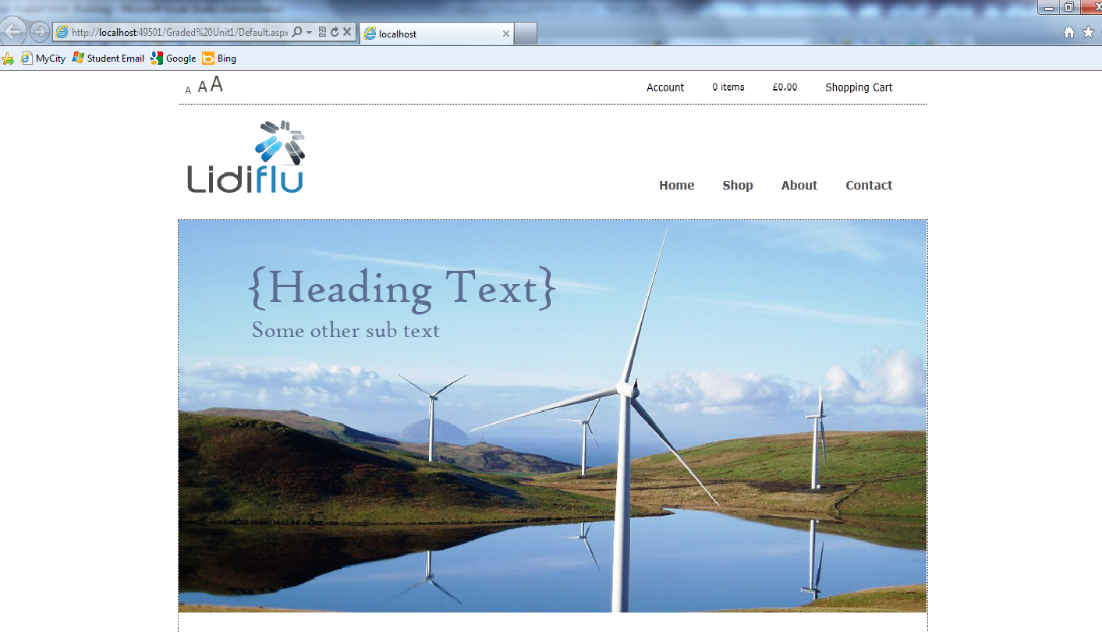

### HTML

<%@ Page Title="" Language="C#" MasterPageFile="~/Lidiflu.Master" AutoEventWireup="true"

CodeFile="Default.aspx.cs" Inherits="_Default" %>

<asp:Content ID="Content1" ContentPlaceHolderID="head" runat="server">

<script src="http://code.jquery.com/jquery-latest.min.js" type="text/javascript"></script>

<script src="Scripts/jquery.slides.min.js" type="text/javascript"></script>

<script type="text/javascript">

$(function () {

$("#slides").slidesjs({

width: 940,

height: 470,

play: {

active: false,

// [boolean] Generate the play and stop buttons.

// You cannot use your own buttons. Sorry.

effect: "slide",

// [string] Can be either "slide" or "fade".

interval: 6000,

// [number] Time spent on each slide in milliseconds.

auto: true,

// [boolean] Start playing the slideshow on load.

swap: false,

// [boolean] show/hide stop and play buttons

pauseOnHover: false,

// [boolean] pause a playing slideshow on hover

restartDelay: 2500

// [number] restart delay on inactive slideshow

}

});

});

</script>

<script type="text/javascript">

//set call function interval

setInterval(getTweets, 42000);

//function to get twitter feed

function getTweets() {

$.getJSON("https://api.twitter.com/1/statuses/user_timeline/Glinner.json?count=5&include_rts=1&callback=?", function (tweetdata) {

var tl = $("#tweet-list");

tl.empty();

$.each(tweetdata, function (i, tweet) {

tl.append("<li class=tweetli>“" + urlToLink(tweet.text) + "”– " + "</br>" + "</br>" + relTime(tweet.created_at) + "</li>");

});

});

}

//converts url to links

function urlToLink(text) {

var exp = /(\b(https?|ftp|file):\/\/[-A-Z0-9+&@#\/%?=~_|!:,.;]*[-A-Z0-9+&@#\/%=~_|])/ig;

return text.replace(exp, "<a href='$1'>$1</a>");

}

//converts post time into twitter style

function relTime(time_value) {

time_value = time_value.replace(/(\+[0-9]{4}\s)/ig, "");

var parsed_date = Date.parse(time_value);

var relative_to = (arguments.length > 1) ? arguments[1] : new Date();

var timeago = parseInt((relative_to.getTime() - parsed_date) / 1000);

if (timeago < 60) return 'less than a minute ago';

else if (timeago < 120) return 'about a minute ago';

else if (timeago < (45 * 60)) return (parseInt(timeago / 60)).toString() + ' minutes ago';

else if (timeago < (90 * 60)) return 'about an hour ago';

else if (timeago < (24 * 60 * 60)) return 'about ' + (parseInt(timeago / 3600)).toString() + ' hours ago';

else if (timeago < (48 * 60 * 60)) return '1 day ago';

else return (parseInt(timeago / 86400)).toString() + ' days ago';

}

</script>

</asp:Content>

<asp:Content ID="Content2" ContentPlaceHolderID="ContentPlaceHolder1" runat="server">

<div id="home-content" class="container_12">

<div id="slides">

<img src="Images/black-law-wind-farm crop.jpg" width="960" height="470" alt="windfarmslide1" />

<img src="Images/SSE-turbines.jpg" width="960" height="470" alt="windfarmslide2" />

<img src="Images/windfarm.jpg" width="960" height="470" alt="windfarmslide3" />

</div>

<asp:Panel ID="pnlWeather" CssClass="container_12" Visible="false" runat="server">

<div id="news_ticker">

<ul>

<li>

<p>

Looks like its getting pretty windy! It is

<asp:Label ID="lblWindSpeed" runat="server" Text="Label"></asp:Label>

mph at your location</p>

</li>

<li><a href="Shop.aspx#category5">Maybe its time to call an engineer!</a> </li>

</ul>

</div>

</asp:Panel>

<div id="products" class="container_12">

<div class="grid_3">

<div class="product-line">

<h2 class="product-header">

Generators</h2>

<a href="Shop.aspx#category1">

<img src="Images/generator.gif" alt="generator" class="product" /></a>

<div class="see-more">

<a href="Shop.aspx#category1">See Product >>></a></div>

</div>

</div>

<div class="grid_3">

<div class="product-line">

<h2 class="product-header">

Gearing</h2>

<a href="Shop.aspx#category2">

<img class="product" src="Images/466116680_485fafec8c_z.jpg" /></a>

<div class="see-more">

<a href="Shop.aspx#category2">See Product >>></a></div>

</div>

</div>

<div class="grid_3">

<div class="product-line">

<h2 class="product-header">

Turbine</h2>

<a href="Shop.aspx#category3">

<img src="Images/turbine.jpg" class="product" /></a>

<div class="see-more">

<a href="Shop.aspx#category3">See Product >>></a></div>

</div>

</div>

<div class="grid_3">

<div class="product-line">

<h2 class="product-header">

Repair Serivces</h2>

<img src="Images/EngineeringServices.png" class="product" alt="engineering services" />

<div class="see-more">

<a href="#">See Service >>></a></div>

</div>

</div>

</div>

<div id="down" class="container_12">

<div id="latests" class="grid_9 clearfix ">

<h2>

Latest Products</h2>

<ul runat="server" class="clearfix" id="latestProducts">

</ul>

</div>

<div id="twitter" class="grid_3 omega">

<div id="twitter-header">

<img src="img/twitter-bird-blue-on-white.png" style="height: 57px; width: 59px" />

<h2>

@lifidlu</h2>

</div>

<ul id="tweet-list">

</ul>

<a href="https://twitter.com/ladyinradiator" class="twitter-follow-button" data-show-count="false">

Follow</a>

<script>!function (d, s, id) { var js, fjs = d.getElementsByTagName(s)[0], p = /^http:/.test(d.location) ? 'http' : 'https'; if (!d.getElementById(id)) { js = d.createElement(s); js.id = id; js.src = p + '://platform.twitter.com/widgets.js'; fjs.parentNode.insertBefore(js, fjs); } } (document, 'script', 'twitter-wjs');</script>

</div>

</div>

</div>

</asp:Content>

### Code Behind

using System;

using System.Collections.Generic;

using System.Linq;

using System.Web;

using System.Web.UI;

using System.Web.UI.WebControls;

using System.Web.UI.HtmlControls;

using System.Collections;

using System.Web.Security;

using System.Xml;

public partial class _Default : System.Web.UI.Page

{

protected DataAccess da;

protected void Page_Load(object sender, EventArgs e)

{

//create customer if customer does not exist in session

try

{

if (HttpContext.Current.Session["Customer"] == null)

{

Customer aCustomer;

aCustomer = CartFunctions.createCustomer();

Session["Customer"] = aCustomer;

}//end if

}//end try

catch (Exception)

{

}//end catch

try

{

//check to see if user is logged on, if so assigns user id to CUSTID in customer object

if (HttpContext.Current.User.Identity.IsAuthenticated)

{

string custID;

Customer aCustomer = (Customer)Session["Customer"];

MembershipUser user = Membership.GetUser();

custID = user.ProviderUserKey.ToString();

aCustomer.CUSTID = custID;

}//end if

}//end try

catch (Exception)

{

}//end catch

try

{

//getWeather();

}//end try

catch (Exception)

{

}//end catch

try

{

//if its a new session get products list from database and add it so session variable

if (Session.IsNewSession)

{

ShopDataContext dc = new ShopDataContext();

da = new DataAccess();

List<Product> p = da.getProducts();

Session["Products"] = p;

}//endif

}//end try

catch (Exception)

{

}//end catch

getLatestProducts();

}

//gets the first 8 products in the products list and displays them on the latest products section

public void getLatestProducts()

{

List<Product> p = (List<Product>)Session["Products"];

try

{

for (int i = 0; i < 8; i++)

{

Product product = p[i];

Image img = new Image();

HyperLink link = new HyperLink();

HtmlGenericControl a = new HtmlGenericControl("a");

HtmlGenericControl newLi = new HtmlGenericControl("li");

string prodID = Convert.ToString(product.ProdID);

img.ImageUrl = product.ProdImage;

img.ID = prodID;

link.NavigateUrl = "Product.aspx?id=" + prodID;

link.Controls.Add(img);

newLi.Controls.Add(link);

latestProducts.Controls.Add(newLi);

}

}

catch (Exception)

{

}

}

//gets the weather from yahoo and parses it for wind speed. if wind speed is greater than ten will display message to get engineering

public void getWeather()

{

XmlDocument myXmlDocument = new XmlDocument();

myXmlDocument.Load("http://weather.yahooapis.com/forecastrss?w=21125");

XmlNamespaceManager ns = new XmlNamespaceManager(myXmlDocument.NameTable);

ns.AddNamespace("yweather", "http://xml.weather.yahoo.com/ns/rss/1.0");

XmlNode node = myXmlDocument.SelectSingleNode("/rss/channel/yweather:wind", ns);

string windSpeed = node.Attributes.GetNamedItem("speed").Value;

int windSpeedInt = Convert.ToInt16(windSpeed);

if (windSpeedInt > 10)

{

lblWindSpeed.Text = windSpeed;

pnlWeather.Visible = true;

}

}//end getWeather

}

## Accout.aspx

### Screenshot

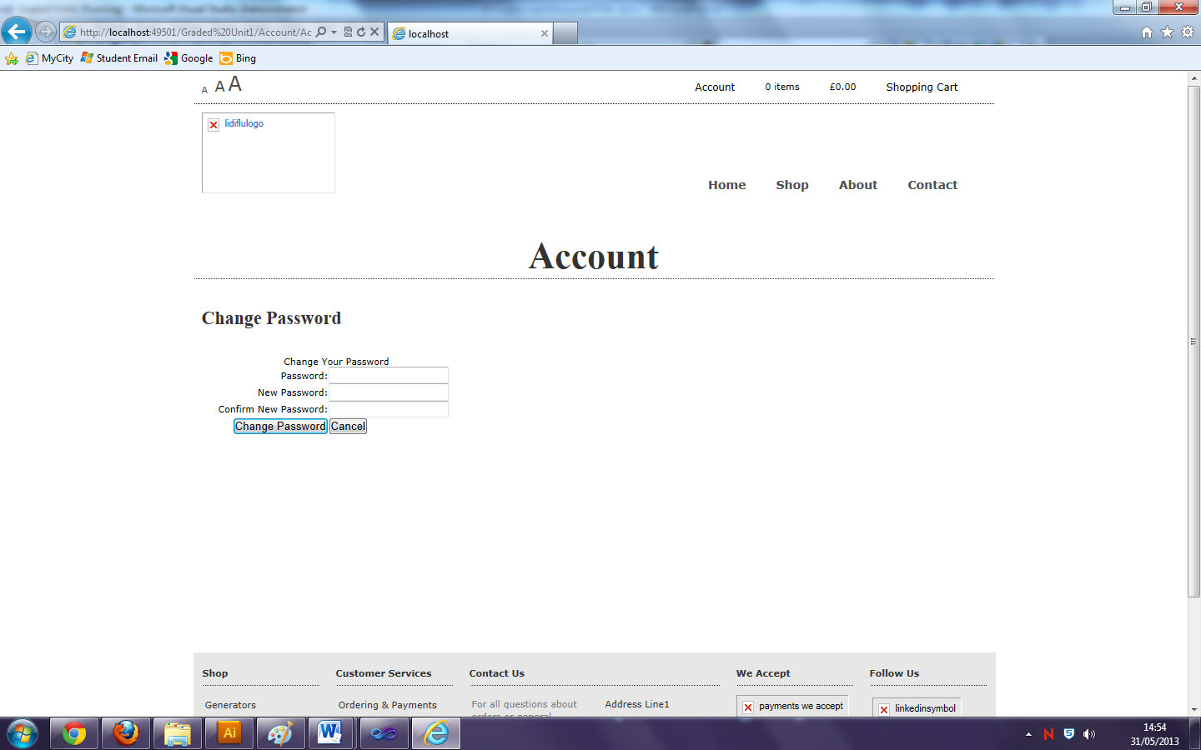

### HTML

<%@ Page Title="" Language="C#" MasterPageFile="~/Lidiflu.Master" AutoEventWireup="true" CodeFile="Account.aspx.cs" Inherits="Account_Account" %>

<asp:Content ID="Content1" ContentPlaceHolderID="head" runat="server">

</asp:Content>

<asp:Content ID="Content2" ContentPlaceHolderID="ContentPlaceHolder1" runat="server">

<div id="title" class="container_12">

<h1>

Account</h1>

</div>

<div class="grid_5">

<h2 class="registerh2">

Change Password</h2>

<div class="registerformwrap">

<asp:ChangePassword ID="ChangePassword1" runat="server">

</asp:ChangePassword>

</div>

</div>

</asp:Content>

### Code Behind

using System;

using System.Collections.Generic;

using System.Linq;

using System.Web;

using System.Web.UI;

using System.Web.UI.WebControls;

public partial class Account_Account : System.Web.UI.Page

{

protected void Page_Load(object sender, EventArgs e)

{

}

}

## Admin.aspx

### Screenshot

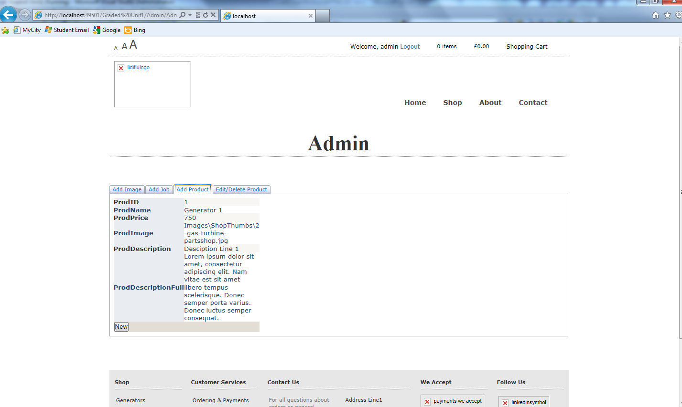

### HTML

<%@ Page Title="" Language="C#" MasterPageFile="~/Lidiflu.Master" AutoEventWireup="true"

CodeFile="Admin.aspx.cs" Inherits="Admin" %>

<%@ Register TagPrefix="asp" Namespace="AjaxControlToolkit" Assembly="AjaxControlToolkit" %>

<asp:Content ID="Content1" ContentPlaceHolderID="head" runat="server">

</asp:Content>

<asp:Content ID="Content2" ContentPlaceHolderID="ContentPlaceHolder1" runat="server">

<script type="text/javascript">

var selectedFiles;

var success = new Boolean("true");

$(document).ready(function () {

// if (!Modernizr.draganddrop) {

// alert("This browser doesn't support File API and Drag & Drop features of HTML5!");

// return;

// } //end if

var box;

box = document.getElementById("box");

box.addEventListener("dragenter", OnDragEnter, false);

box.addEventListener("dragover", OnDragOver, false);

box.addEventListener("drop", OnDrop, false);

box.addEventListener("dragleave", OnLeave, false);

$("#upload").click(function () {

if (success) {

var data = new FormData();

for (var i = 0; i < selectedFiles.length; i++) {

data.append(selectedFiles[i].name, selectedFiles[i]);

} //end for

$.ajax({

type: "POST",

url: "FileHandler.ashx",

contentType: false,

processData: false,

data: data,

success: function (result) {

alert(result);

success = true;

},

error: function () {

alert("There was error uploading files!");

}

}); //end ajax

} //end if

else {

$("#box").text("the files you have selected are not valid");

} //end else

}); //end function ready

}); //end click

function OnDragEnter(e) {

this.style.opacity = '0.4';

$("#box").addClass("dragEnterBox");

e.stopPropagation();

e.preventDefault();

} //end OnDragEnter

function OnDragOver(e) {

$("#box").addClass("dragEnterBox");

e.stopPropagation();

e.preventDefault();

} //end OnDragOver

function OnLeave(e) {

this.style.opacity = '1';

e.stopPropagation();

e.preventDefault();

}

var mimeType

function OnDrop(e) {

this.style.opacity = '1';

$("#box").addClass("dragEnterBox");

e.stopPropagation();

e.preventDefault();

selectedFiles = e.dataTransfer.files;

for (var i = 0; i < selectedFiles.length; i++) {

mimeType = selectedFiles[i].type;

typeValidate = (mimeType.substring(0, 5));

if (typeValidate == "image") {

$("#box").text(selectedFiles.length + " file(s) selected for uploading!");

success = true;

}

else {

$("#box").text("some or all of your files are not images");

success = false;

//selectedFiles.length=0;

} //end if else

} //end for

} //end OnDrop

</script>

<div id="title" class="container_12">

<h1>

Admin</h1>

</div>

<div id="admin-container" class="container_12">

<asp:ToolkitScriptManager ID="ToolkitScriptManager1" runat="server">

</asp:ToolkitScriptManager>

<asp:TabContainer ID="TabContainer1" runat="server" ActiveTabIndex="3">

<asp:TabPanel runat="server" ID="AddImage" HeaderText="Add Image">

<ContentTemplate>

<div id="box">

Drag &amp; Drop files from your machine on this box.</div>

<br />

<input id="upload" type="button" value="Upload Selected Files" class="button-link" />

</ContentTemplate>

</asp:TabPanel>

<asp:TabPanel runat="server" ID="AddJob" HeaderText="Add Job">

<ContentTemplate>

<%-- <asp:DetailsView ID="DetailsView2" runat="server" Height="16px" Width="225px" AutoGenerateRows="False"

AutoGenerateInsertButton="True" DataKeyNames="JobID" DataSourceID="LinqDataSource1">

<Fields>

<asp:BoundField DataField="JobID" HeaderText="JobID" ReadOnly="True" SortExpression="JobID" />

<asp:BoundField DataField="JobTitle" HeaderText="JobTitle" SortExpression="JobTitle" />

<asp:BoundField DataField="JobDescription" HeaderText="JobDescription" SortExpression="JobDescription" />

<asp:BoundField DataField="JobLocation" HeaderText="JobLocation" SortExpression="JobLocation" />

<asp:CheckBoxField DataField="Assigned" HeaderText="Assigned" SortExpression="Assigned" />

<asp:BoundField DataField="JobDate" HeaderText="JobDate" SortExpression="JobDate" />

<asp:CheckBoxField DataField="Completed" HeaderText="Completed" SortExpression="Completed" />

<asp:BoundField DataField="long" HeaderText="long" SortExpression="long" />

<asp:BoundField DataField="lat" HeaderText="lat" SortExpression="lat" />

</Fields>

</asp:DetailsView>

<asp:LinqDataSource ID="LinqDataSource1" runat="server" ContextTypeName="EngineerDataContext"

EnableDelete="True" EnableInsert="True" EnableUpdate="True" EntityTypeName=""

TableName="Jobs">

</asp:LinqDataSource>--%>

</ContentTemplate>

</asp:TabPanel>

<asp:TabPanel runat="server" ID="AddProduct" HeaderText="Add Product">

<ContentTemplate>

<asp:DetailsView ID="DetailsView1" runat="server" Height="50px" Width="125px" AutoGenerateRows="False"

CellPadding="4" DataKeyNames="ProdID" DataSourceID="ProductLinqDataSource1" ForeColor="#333333"

GridLines="None">

<AlternatingRowStyle BackColor="White" ForeColor="#284775" />

<CommandRowStyle BackColor="#E2DED6" Font-Bold="True" />

<EditRowStyle BackColor="#999999" />

<FieldHeaderStyle BackColor="#E9ECF1" Font-Bold="True" />

<Fields>

<asp:BoundField DataField="ProdID" HeaderText="ProdID" InsertVisible="False" ReadOnly="True"

SortExpression="ProdID" />

<asp:BoundField DataField="ProdName" HeaderText="ProdName" SortExpression="ProdName" />

<asp:BoundField DataField="ProdPrice" HeaderText="ProdPrice" SortExpression="ProdPrice" />

<asp:BoundField DataField="ProdImage" HeaderText="ProdImage" SortExpression="ProdImage" />

<asp:BoundField DataField="ProdDescription" HeaderText="ProdDescription" SortExpression="ProdDescription" />

<asp:BoundField DataField="ProdDescriptionFull" HeaderText="ProdDescriptionFull"

SortExpression="ProdDescriptionFull" />

<asp:CommandField ButtonType="Button" ShowInsertButton="True" />

</Fields>

<FooterStyle BackColor="#5D7B9D" Font-Bold="True" ForeColor="White" />

<HeaderStyle BackColor="#5D7B9D" Font-Bold="True" ForeColor="White" />

<PagerStyle BackColor="#284775" ForeColor="White" HorizontalAlign="Center" />

<RowStyle BackColor="#F7F6F3" ForeColor="#333333" />

</asp:DetailsView>

<asp:LinqDataSource ID="ProductLinqDataSource1" runat="server" ContextTypeName="ShopDataContext"

EnableInsert="True" EntityTypeName="" TableName="Products">

</asp:LinqDataSource>

</ContentTemplate>

</asp:TabPanel>

<asp:TabPanel ID="EditProduct" runat="server" HeaderText="Edit/Delete Product">

<ContentTemplate>

<div id="editProduct">

<asp:GridView ID="GridView1" runat="server" AllowSorting="True" AutoGenerateColumns="False"

DataKeyNames="ProdID" DataSourceID="ProductDataSource1" AllowPaging="True" PageSize="5"

CellPadding="4" ForeColor="#333333" GridLines="None">

<AlternatingRowStyle BackColor="White" ForeColor="#284775" />

<Columns>

<asp:CommandField ShowDeleteButton="True" ShowEditButton="True" />

<asp:BoundField DataField="ProdID" HeaderText="ProdID" ReadOnly="True" SortExpression="ProdID" />

<asp:BoundField DataField="ProdName" HeaderText="ProdName" SortExpression="ProdName" />

<asp:BoundField DataField="ProdPrice" HeaderText="ProdPrice" SortExpression="ProdPrice" />

<asp:BoundField DataField="ProdImage" HeaderText="ProdImage" SortExpression="ProdImage" />

<asp:BoundField DataField="ProdDescription" HeaderText="ProdDescription" SortExpression="ProdDescription" />

<asp:BoundField DataField="ProdDescriptionFull" HeaderText="ProdDescriptionFull"

SortExpression="ProdDescriptionFull" />

</Columns>

<EditRowStyle BackColor="#999999" />

<FooterStyle BackColor="#5D7B9D" Font-Bold="True" ForeColor="White" />

<HeaderStyle BackColor="#5D7B9D" Font-Bold="True" ForeColor="White" />

<PagerStyle BackColor="#284775" ForeColor="White" HorizontalAlign="Center" />

<RowStyle BackColor="#F7F6F3" ForeColor="#333333" />

<SelectedRowStyle BackColor="#E2DED6" Font-Bold="True" ForeColor="#333333" />

<SortedAscendingCellStyle BackColor="#E9E7E2" />

<SortedAscendingHeaderStyle BackColor="#506C8C" />

<SortedDescendingCellStyle BackColor="#FFFDF8" />

<SortedDescendingHeaderStyle BackColor="#6F8DAE" />

</asp:GridView>

<asp:LinqDataSource ID="ProductDataSource1" runat="server" ContextTypeName="ShopDataContext"

EnableDelete="True" EnableUpdate="True" EnableInsert="True" EntityTypeName=""

TableName="Products">

</asp:LinqDataSource>

</div>

</ContentTemplate>

</asp:TabPanel>

</asp:TabContainer>

</div>

</asp:Content>

### Code Behind

using System;

using System.Collections.Generic;

using System.Linq;

using System.Web;

using System.Web.UI;

using System.Web.UI.WebControls;

public partial class Admin : System.Web.UI.Page

{

protected void Page_Load(object sender, EventArgs e)

{

}

}

## CheckoutCancel.aspx

### Screenshot

### HTML

<%@ Page Title="" Language="C#" MasterPageFile="~/Lidiflu.Master" AutoEventWireup="true" CodeFile="CheckoutCancel.aspx.cs" Inherits="CheckoutCancel" %>

<asp:Content ID="Content1" ContentPlaceHolderID="head" Runat="Server">

</asp:Content>

<asp:Content ID="Content2" ContentPlaceHolderID="ContentPlaceHolder1" Runat="Server">

</asp:Content>

### Code Behind

using System;

using System.Collections.Generic;

using System.Linq;

using System.Web;

using System.Web.UI;

using System.Web.UI.WebControls;

public partial class CheckoutCancel : System.Web.UI.Page

{

protected void Page_Load(object sender, EventArgs e)

{

}

}

## CheckoutComplete.aspx

### Screenshot

### HTML

<%@ Page Title="" Language="C#" MasterPageFile="~/Lidiflu.Master" AutoEventWireup="true" CodeFile="CheckoutComplete.aspx.cs" Inherits="CheckoutComplete" %>

<asp:Content ID="Content1" ContentPlaceHolderID="head" runat="server">

</asp:Content>

<asp:Content ID="Content2" ContentPlaceHolderID="ContentPlaceHolder1" runat="server">

<h1>Checkout Complete</h1>

<p></p>

<h3>Payment Transaction ID:</h3> <asp:Label ID="TransactionId" runat="server"></asp:Label>

<p></p>

<h3>Thank You!</h3>

<p></p>

<hr />

<asp:Button ID="Continue" runat="server" Text="Continue Shopping" OnClick="Continue_Click" />

</asp:Content>

### Code Behind

using System;

using System.Collections.Generic;

using System.Linq;

using System.Web;

using System.Web.UI;

using System.Web.UI.WebControls;

public partial class CheckoutComplete : System.Web.UI.Page

{

protected void Page_Load(object sender, EventArgs e)

{

if (!IsPostBack)

{

// Verify user has completed the checkout process.

if (Session["userCheckoutCompleted"] != "true")

{

Session["userCheckoutCompleted"] = "";

Response.Redirect("CheckoutError.aspx?" + "Desc=Unvalidated%20Checkout.");

}

NVPAPICaller payPalCaller = new NVPAPICaller();

string retMsg = "";

string token = "";

string finalPaymentAmount = "";

string PayerID = "";

NVPCodec decoder = new NVPCodec();

token = Session["token"].ToString();

PayerID = Session["payerId"].ToString();

finalPaymentAmount = Session["payment_amt"].ToString();

bool ret = payPalCaller.DoCheckoutPayment(finalPaymentAmount, token, PayerID, ref decoder, ref retMsg);

if (ret)

{

// Retrieve PayPal confirmation value.

string PaymentConfirmation = decoder["PAYMENTINFO_0_TRANSACTIONID"].ToString();

TransactionId.Text = PaymentConfirmation;

// Get dataaccess context.

DataAccess da = new DataAccess();

Customer aCustomer = (Customer)Session["Customer"];

aCustomer.Orders[0].OrderID = PaymentConfirmation;

aCustomer = CartFunctions.setOrderId(aCustomer, PaymentConfirmation);

// Add order to DB.

da.addCustomer(aCustomer);

da.addOrder(aCustomer);

da.addOrderline(aCustomer);

// Clear Order

aCustomer = CartFunctions.clearOrder(aCustomer);

}

else

{

Response.Redirect("CheckoutError.aspx?" + retMsg);

}

}

}

protected void Continue_Click(object sender, EventArgs e)

{

Response.Redirect("~/Default.aspx");

}

}

## CheckoutError.aspx

### Screenshot

### HTML

<%@ Page Title="" Language="C#" MasterPageFile="~/Lidiflu.Master" AutoEventWireup="true" CodeFile="CheckoutError.aspx.cs" Inherits="CheckoutError" %>

<asp:Content ID="Content1" ContentPlaceHolderID="head" runat="server">

</asp:Content>

<asp:Content ID="Content2" ContentPlaceHolderID="ContentPlaceHolder1" runat="server">

<h1>Checkout Error</h1>

<p></p>

<table id="ErrorTable">

<tr>

<td class="field"></td>

<td><%=Request.QueryString.Get("ErrorCode")%></td>

</tr>

<tr>

<td class="field"></td>

<td><%=Request.QueryString.Get("Desc")%></td>

</tr>

<tr>

<td class="field"></td>

<td><%=Request.QueryString.Get("Desc2")%></td>

</tr>

</table>

<p></p>

</asp:Content>

### Code Behind

using System;

using System.Collections.Generic;

using System.Linq;

using System.Web;

using System.Web.UI;

using System.Web.UI.WebControls;

public partial class CheckoutError : System.Web.UI.Page

{

protected void Page_Load(object sender, EventArgs e)

{

}

}

## CheckoutReview.aspx

### Screenshot

### HTML

<%@ Page Title="" Language="C#" MasterPageFile="~/Lidiflu.Master" AutoEventWireup="true"

CodeFile="CheckoutReview.aspx.cs" Inherits="CheckoutReview" %>

<asp:Content ID="Content1" ContentPlaceHolderID="head" runat="server">

</asp:Content>

<asp:Content ID="Content2" ContentPlaceHolderID="ContentPlaceHolder1" runat="server">

<div id="title" class="container_12">

<h1>

Checkout</h1>

</div>

<div id="checkout-container" class="grid_9">

<div id="details">

<h2 class="checkouth2">

1. Your Details</h2>

<h4>

Forename</h4>

<asp:Label ID="lblFore" runat="server" Height="23px" Width="295px"></asp:Label>

<h4>

Surname</h4>

<asp:Label ID="lblSur" runat="server" Height="23px" Width="295px"></asp:Label>

<h4>

Email</h4>

<asp:Label ID="lblEmail" type="email" runat="server" Height="23px" Width="295px"></asp:Label>

</div>

<div id="address">

<h2 class="checkouth2">

2. Shipping Address</h2>

<h4>

Address Line 1</h4>

<asp:Label ID="lblAddress" runat="server" Height="23px" Width="295px"></asp:Label>

<h4>

Town/City</h4>

<asp:Label ID="lblCity" runat="server" Height="23px" Width="295px"></asp:Label>

<h4>

PostCode</h4>

<asp:Label ID="lblPostCode" runat="server" Height="23px" Width="295px"></asp:Label>

</div>

<div id="confirmation">

<h2 class="checkouth2">

3. Order Summary</h2>

<asp:GridView ID="GridView1" Width="100%" AutoGenerateColumns="False" runat="server"

RowStyle-VerticalAlign="Top" RowStyle-HorizontalAlign="Left" CellPadding="5"

BorderStyle="Dotted" BorderWidth="0px" Font-Size="8pt" Font-Names="Verdana" ForeColor="#333333">

<HeaderStyle HorizontalAlign="Left" />

<RowStyle BorderStyle="Dotted" BorderWidth="1px" Font-Names="Verdana" Font-Size="11px" />

<Columns>

<asp:TemplateField ControlStyle-Width="140" HeaderText="Product" SortExpression="Product">

<ItemTemplate>

<asp:Label ID="lblDescript" runat="server" Text='<%#Eval("Name") %>' />

</ItemTemplate>

<ControlStyle Width="220px"></ControlStyle>

</asp:TemplateField>

<asp:TemplateField HeaderText="Price" ControlStyle-Width="60" SortExpression="Price">

<ItemTemplate>

<asp:Label ID="lblPrice" runat="server" Text='<%#Eval("Price") %>' />

</ItemTemplate>

<ControlStyle Width="60px"></ControlStyle>

</asp:TemplateField>

<asp:TemplateField HeaderText="Qty" ControlStyle-Width="80" SortExpression="Price">

<ItemTemplate>

<asp:Label Width="20px" Height="20px" ID="txtQty" runat="server" Text='<%#Eval("Qty") %>' />

</ItemTemplate>

<ControlStyle Width="80px"></ControlStyle>

</asp:TemplateField>

<asp:TemplateField HeaderText="Total" ControlStyle-Width="120" ItemStyle-HorizontalAlign="Right"

SortExpression="Total">

<ItemTemplate>

<asp:Label ID="lblTotal" runat="server" Text='<%#Eval("Total") %>' />

</ItemTemplate>

<ControlStyle Width="120px"></ControlStyle>

<ItemStyle HorizontalAlign="Right"></ItemStyle>

</asp:TemplateField>

</Columns>

</asp:GridView>

<div id="proceed" class="grid_3 prefix_6 alpha">

<asp:Table ID="Table1" runat="server" Height="53px" Width="166px">

<asp:TableRow>

<asp:TableCell><p>Sub Total</p></asp:TableCell>

<asp:TableCell ID="cellSub"></asp:TableCell>

</asp:TableRow>

<asp:TableRow>

<asp:TableCell><p>Shipping</p></asp:TableCell>

<asp:TableCell ID="cellShipping"></asp:TableCell>

</asp:TableRow>

<asp:TableRow>

<asp:TableCell><p>Total</p></asp:TableCell>

<asp:TableCell ID="cellTotal"></asp:TableCell>

</asp:TableRow>

</asp:Table>

<br />

<br />

<asp:Button runat="server" CssClass="btnAddToCart" ID="btnConfrim" Text="Confirm Order"

OnClick="btnConfrim_Click" />

</div>

</div>

</div>

<div id="cartside" class="grid_3 omega">

<h2>

Need Help</h2>

<p class="grey-text">

Office Hours:<br></br>

Mon-Fri 9.30am-6.00pm</p>

<p>

</p>

<p>

+44 (0) 1313 123 1235</p>

<p>

</p>

<p>

<a style="color: #2583B7" href="mailto:enquiries@lidiflu.com">enquiries@lidiflu.com</a></p>

<h2>

We Accept</h2>

<img src="Images/paymentsmall.png" />

<h2>

Delivery</h2>

<p>

We ship with UPS and a Special delivery service from Royal mail.</p>

<p>

<br></br>

</p>

<p>

UK ORDERS We aim to get all orders placed before 3pm out to you for a next day delivery.

</p>

<h2>

Returns</h2>

<p>

<a href="#">Returns and Delivery >> </a>

</p>

</div>

</asp:Content>

### Code Behind

using System;

using System.Collections.Generic;

using System.Linq;

using System.Web;

using System.Web.UI;

using System.Web.UI.WebControls;

public partial class CheckoutReview : System.Web.UI.Page

{

protected void Page_Load(object sender, EventArgs e)

{

double subTotal = 0;

double total = 0;

double shipping = 00;

if (!IsPostBack)

{

NVPAPICaller payPalCaller = new NVPAPICaller();

string retMsg = "";

string token = "";

string PayerID = "";

string foreName = "";

string surName = "";

string email = "";

string address = "";

string postcode = "";

string town = "";

NVPCodec decoder = new NVPCodec();

token = Session["token"].ToString();

bool ret = payPalCaller.GetCheckoutDetails(token, ref PayerID, ref decoder, ref retMsg);

if (ret)

{

//get user information from papal

Session["payerId"] = PayerID;

foreName = decoder["FIRSTNAME"].ToString();

surName = decoder["LASTNAME"].ToString();

address = decoder["SHIPTOSTREET"].ToString();

town = decoder["SHIPTOCITY"].ToString();

postcode = decoder["SHIPTOZIP"].ToString();

email = decoder["EMAIL"].ToString();

//display user information

lblFore.Text = foreName;

lblSur.Text = surName;

lblCity.Text = town;

lblEmail.Text = email;

lblPostCode.Text = postcode;

lblAddress.Text = address;

//set customer object with information from paypal

Customer aCustomer = (Customer)Session["Customer"];

aCustomer.CityAddress = town;

aCustomer.Email = email;

aCustomer.FName = foreName;

aCustomer.SName = surName;

aCustomer.StreetAddress = address;

aCustomer.PostCode = postcode;

// Verify total payment amount as set on CheckoutStart.aspx.

try

{

decimal paymentAmountOnCheckout = Convert.ToDecimal(Session["payment_amt"].ToString());

decimal paymentAmoutFromPayPal = Convert.ToDecimal(decoder["AMT"].ToString());

shipping = Convert.ToDouble(decoder["SHIPPINGAMT"].ToString());

if (paymentAmountOnCheckout != paymentAmoutFromPayPal)

{

Response.Redirect("CheckoutError.aspx?" + "Desc=Amount%20total%20mismatch.");

}

}

catch (Exception)

{

Response.Redirect("CheckoutError.aspx?" + "Desc=Amount%20total%20mismatch.");

}

// Display Order information.

var query = from goods in aCustomer.Orders[0].OrderLines

select new

{

Name = goods.Product.ProdName,

Description = goods.Product.ProdDescription,

Price = goods.Product.ProdPrice,

Qty = goods.Quantity,

Total = "£" + Convert.ToString(goods.Quantity * goods.Product.ProdPrice),

ProdImage = goods.Product.ProdImage

};

GridView1.DataSource = query;

GridView1.DataBind();

subTotal = CartFunctions.getSubTotal(aCustomer);

cellSub.Text = "£" + Convert.ToString(subTotal);

total = subTotal + shipping;

cellTotal.Text = "£" + total;

cellShipping.Text = shipping.ToString();

}

else

{

Response.Redirect("CheckoutError.aspx?" + retMsg);

}

}

}

protected void btnConfrim_Click(object sender, EventArgs e)

{

Session["userCheckoutCompleted"] = "true";

Response.Redirect("~/CheckoutComplete.aspx");

}

}

## Contact.aspx

### Screenshot

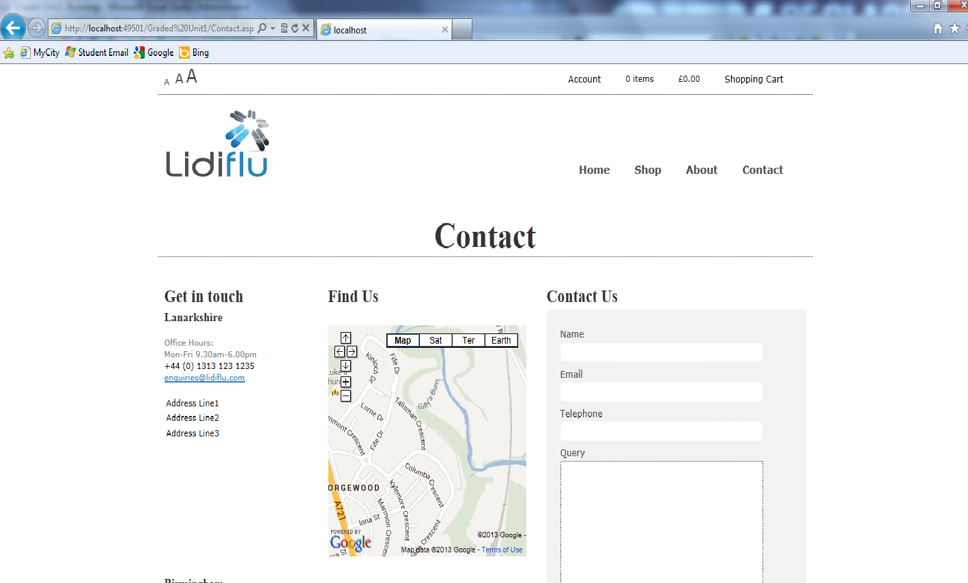

### HTML

<%@ Page Title="" Language="C#" MasterPageFile="~/Lidiflu.Master" AutoEventWireup="true"

CodeFile="Contact.aspx.cs" Inherits="Contact" %>

<asp:Content ID="Content1" ContentPlaceHolderID="head" runat="server">

</asp:Content>

<asp:Content ID="Content2" ContentPlaceHolderID="ContentPlaceHolder1" runat="server">

<div id="title" class="container_12">

<h1>

Contact</h1>

</div>

<div class="grid_7">

<h2 class="contacth2 grid_3 alpha">

Get in touch</h2>

<h2 class="contacth2 grid_4 omega">

Find Us</h2>

<div class="grid_7 dottedline alpha">

</div>

<div class="grid_3 intouch alpha">

<h3 class="contacth3">

Lanarkshire</h3>

<p class="grey-text">

Office Hours:</br>Mon-Fri 9.30am-6.00pm</p>

<p>

</p>

<p>

+44 (0) 1313 123 1235</p>

<p>

</p>

<p>

</p>

<p>

<a style="color: #2583B7" href="mailto:enquiries@lidiflu.com">enquiries@lidiflu.com</a></p>

<ul class="contactul">

<li class="contactli">Address Line1</li>

<li class="contactli">Address Line2</li>

<li class="contactli">Address Line3</li>

</ul>

</div>

<div class="grid_4 findus omega">

<iframe width="290" height="300" frameborder="0" scrolling="no" marginheight="0"

marginwidth="0" src="https://maps.google.co.uk/maps?f=q&amp;source=s_q&amp;hl=en&amp;geocode=&amp;q=&amp;aq=&amp;sll=55.78362,-3.994217&amp;sspn=0.026207,0.084543&amp;ie=UTF8&amp;t=m&amp;ll=55.804995,-3.998423&amp;spn=0.006753,0.011973&amp;z=15&amp;output=embed">

</iframe>

<br />

</div>

<div class="grid_7 dottedline alpha">

</div>

<div class="intouch grid_3 alpha">

<h3 class="contacth3">

Birmingham</h3>

<p class="grey-text">

Office Hours:</br>Mon-Fri 9.30am-6.00pm</p>

<p>

</p>

<p>

+44 (0) 3423 123 1235</p>

<p>

</p>

<p>

</p>

<p>

<a style="color: #2583B7" href="mailto:enquiries@lidiflu.com">enquiries@lidiflu.com</a></p>

<ul class="contactul">

<li class="contactli">Address Line1</li>

<li class="contactli">Address Line2</li>

<li class="contactli">Address Line3</li>

</ul>

</div>

<div class="findus grid_4 omega">

<iframe width="290" height="300" frameborder="0" scrolling="no" marginheight="0"

marginwidth="0" src="https://maps.google.co.uk/maps?f=q&amp;source=s_q&amp;hl=en&amp;geocode=&amp;q=&amp;aq=&amp;sll=55.78362,-3.994217&amp;sspn=0.026207,0.084543&amp;ie=UTF8&amp;t=m&amp;ll=55.804995,-3.998423&amp;spn=0.006753,0.011973&amp;z=15&amp;output=embed">

</iframe>

</div>

</div>

<div class="grid_5 messageus float-right">

<h2 class="contacth2 grid_5 alpha">

Contact Us</h2>

<div class="grid_5 dottedline alpha">

</div>

<div id="formWrap" class="grid_5">

<div class="row">

<div class="label">

Name</div>

</div>

<div class="row">

<!--endlabel-->

<div class="input">

<asp:TextBox type="text" ID="name" class="details" runat="server" required="required"

placeholder="Your Full Name"></asp:TextBox>

</div>

<!--end of class-->

</div>

<div class="row">

<div class="label">

Email</div>

</div>

<div class="row">

<!--endlabel-->

<div class="input">

<asp:TextBox type="email" ID="email" class="details" runat="server" required="required"

placeholder="Email Address"></asp:TextBox>

</div>

<!--end of class-->

</div>

<div class="row">

<div class="label">

Telephone</div>

</div>

<div class="row">

<!--endlabel-->

<div class="input">

<asp:TextBox type="text" ID="tel" class="details" runat="server" required="required"

placeholder="Telephone Number"></asp:TextBox>

</div>

<!--end of class-->

</div>

<!--end row-->

<div class="row">

<div class="label">

Query</div>

</div>

<!--endlabel-->

<div class="row">

<div class="input">

<asp:TextBox runat="server" ID="query" class="mess" TextMode="MultiLine" required="required"

placeholder="Whats your query?"></asp:TextBox>

</div>

</div>

<!--end of class-->

<asp:RequiredFieldValidator class="servervalidator" ForeColor="Red" Display="Dynamic"

ID="RequiredFieldValidator1" runat="server" ControlToValidate="name" ErrorMessage="Please Enter Your Name"></asp:RequiredFieldValidator>

<asp:RequiredFieldValidator class="servervalidator" ID="RequiredFieldValidator2"

runat="server" ControlToValidate="email" ErrorMessage="Please Enter a Valid Email Address"></asp:RequiredFieldValidator>

<asp:RequiredFieldValidator class="servervalidator" ID="RequiredFieldValidator3"

runat="server" ControlToValidate="query" ErrorMessage="Please Enter Your Query"></asp:RequiredFieldValidator>

<asp:Panel ID="pnlConfirmation" Visible="false" runat="server">

<p>

Thank you For Enquiry</p>

</asp:Panel>

<asp:Panel ID="pnlFailed" Visible="false" runat="server">

<p>

Sorry message was not sent!</p>

</asp:Panel>

<asp:Button ID="submit" class="button-link" runat="server" Height="36px" Width="65px"

Text="Submit" OnClick="submit_Click" />

</div>

</div>

</asp:Content>

### Code Behind

using System;

using System.Collections.Generic;

using System.Linq;

using System.Web;

using System.Web.UI;

using System.Web.UI.WebControls;

using System.Net;

public partial class Contact : System.Web.UI.Page

{

protected void Page_Load(object sender, EventArgs e)

{

}

protected void SendMail()

{

// Gmail Address from where you send the mail

var fromAddress = email.Text.ToString();

// any address where the email will be sending

var toAddress = "niall.ferguson@gmail.com";

//Password of your gmail address

const string fromPassword = "kissme9";

// Passing the values and make a email formate to display

string subject = "Lidiflu Enquiry";

string body = "From: " + name.Text + "\n";

body += "Email: " + email.Text + "\n";

body += "Telephone: " + tel.Text + "\n";

body += "Query: " + query.Text + "\n";

// smtp settings

var smtp = new System.Net.Mail.SmtpClient();

{

smtp.Host = "smtp.gmail.com";

smtp.Port = 587;

smtp.EnableSsl = true;

smtp.DeliveryMethod = System.Net.Mail.SmtpDeliveryMethod.Network;

smtp.Credentials = new NetworkCredential(toAddress, fromPassword);

smtp.Timeout = 20000;

}

// Passing values to smtp object

smtp.Send(fromAddress, toAddress, subject, body);

}

protected void clearForm()

{

email.Text = "";

name.Text = "";

tel.Text = "";

query.Text = "";

}

protected void submit_Click(object sender, EventArgs e)

{

try

{

//here on button click what will done

SendMail();

clearForm();

pnlConfirmation.Visible = true;

}

catch (Exception)

{

pnlFailed.Visible = true;

}

}

}

## Products.aspx

### Screenshot

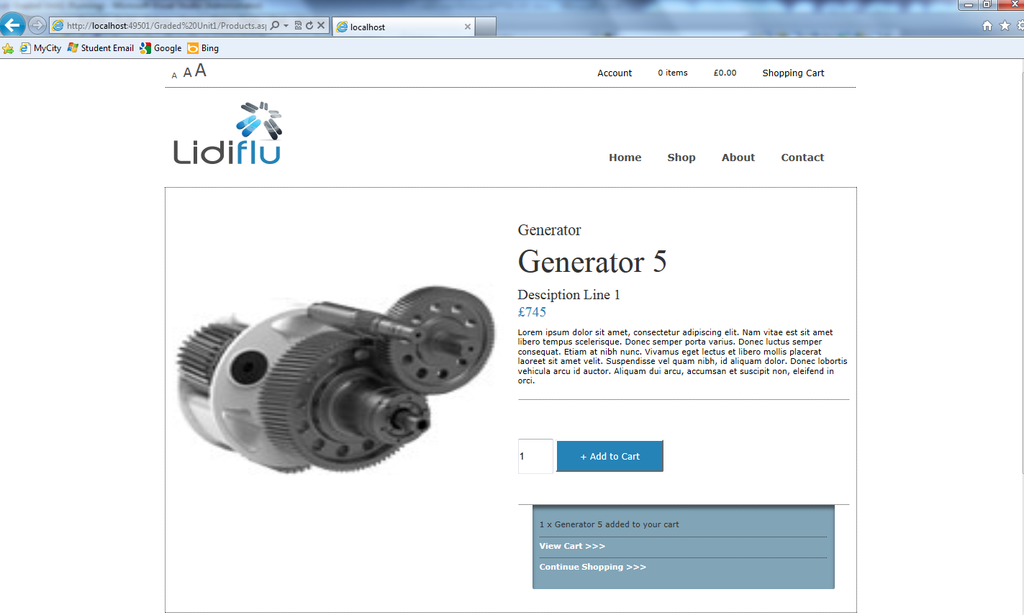

### HTML

<%@ Page Title="" Language="C#" MasterPageFile="~/Lidiflu.Master" AutoEventWireup="true"

CodeFile="Products.aspx.cs" Inherits="Products" %>

<%@ Register Assembly="AjaxControlToolkit" Namespace="AjaxControlToolkit" TagPrefix="asp" %>

<asp:Content ID="Content1" ContentPlaceHolderID="head" runat="server">

<script src="http://code.jquery.com/jquery-latest.min.js" type="text/javascript"></script>

</asp:Content>

<asp:Content ID="Content2" ContentPlaceHolderID="ContentPlaceHolder1" runat="server">

<script type="text/javascript">

//display panel after add to cart

function confirmOrder() {

$("#options").slideToggle("slow");

$(this).toggleClass("active");

}

</script>

<div id="innercontent" class="container_12">

<div class="grid_6">

<div id="proddisplay">

<asp:Image ID="imgProdImage" runat="server" Height="360px" Width="100%" />

</div>

<div class="productalt grid_2 alpha">

</div>

<div class="productalt grid_2">

</div>

<div class="productalt grid_2 omega">

</div>

</div>

<div class="grid_6">

<div id="prodinfo">

<asp:Label ID="lblCategory" CssClass="prodinfocategory" runat="server" Text="Category"></asp:Label>

<asp:Label ID="lblProdTitle" CssClass="prodinfotitle" runat="server" Text="Item Title"></asp:Label>

<asp:Label ID="lblSubHeading" runat="server" CssClass="prodinfosubhead" Text="SubHeading"></asp:Label>

<asp:Label ID="lblPrice" CssClass="price" runat="server" Text="£123.00"></asp:Label>

<asp:Label ID="lblDescription" runat="server" Text="Label"></asp:Label>

</div>

<div id="addto">

<asp:TextBox type="number" Width="45px" Height="45px" min="1" value="1" ID="txtQuantity"

runat="server"></asp:TextBox>

<asp:Button ID="addtoCart" CssClass="btnAddToCart" runat="server" Text="+ Add to Cart"

OnClick="addtoCart_Click" />

</div>

<div id="options">

<asp:Label ID="lblQty" CssClass="prodLabel" runat="server" Text=""></asp:Label><asp:Label

CssClass="prodLabel" ID="lblProduct" runat="server" Text=""></asp:Label>

<a href="ShoppingCart.aspx">View Cart >>></a> <a href="Shop.aspx">Continue Shopping

>>></a>

</div>

</div>

</div>

</asp:Content>

### Code Behind

using System;

using System.Collections.Generic;

using System.Linq;

using System.Web;

using System.Web.UI;

using System.Web.UI.WebControls;

public partial class Products : System.Web.UI.Page

{

protected void Page_Load(object sender, EventArgs e)

{

//get id from query string if not empty

if (Request.QueryString["id"] != null)

{

int id = Convert.ToInt16(Request.QueryString["id"]);

List<Product> p = (List<Product>)Session["Products"];

foreach (Product product in p)

{

//if the product in product list matches id display product information

if (product.ProdID == id)

{

lblPrice.Text = "£" + Convert.ToString(product.ProdPrice);

lblProdTitle.Text = product.ProdName;

imgProdImage.ImageUrl = product.ProdImage;

lblSubHeading.Text = product.ProdDescription;

lblDescription.Text = product.ProdDescriptionFull;

lblCategory.Text = CartFunctions.getCategory(product.ProdID);

}

}

}

}

protected void addtoCart_Click(object sender, EventArgs e)

{

//add certain number of selected product to cart

List<Product> p = (List<Product>)Session["Products"];

Customer aCustomer = (Customer)Session["Customer"];

int qty = Convert.ToInt16(txtQuantity.Text);

int prodId = Convert.ToInt16(Request.QueryString["id"]);

aCustomer = CartFunctions.addItemtoCart(p, aCustomer, prodId, qty);

lblQty.Text = txtQuantity.Text + " ";

lblProduct.Text = "x " + lblProdTitle.Text + " added to your cart";

Session["Customer"] = aCustomer;

//displays products bought with

ClientScript.RegisterStartupScript(GetType(), "hwa", "confirmOrder();", true);

}

}

## Register.aspx

### Screenshot

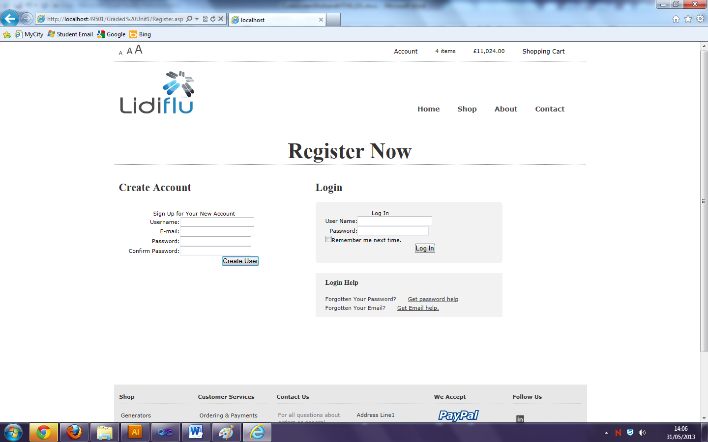

### HTML

<%@ Page Title="" Language="C#" MasterPageFile="~/Lidiflu.Master" AutoEventWireup="true"

CodeFile="Register.aspx.cs" Inherits="Register" %>

<asp:Content ID="Content1" ContentPlaceHolderID="head" runat="server">

<style type="text/css">

.style1

{

height: 15px;

}

</style>

</asp:Content>

<asp:Content ID="Content2" ContentPlaceHolderID="ContentPlaceHolder1" runat="server">

<div id="title" class="container_12">

<h1>

Register Now</h1>

</div>

<div id="register-left" class="grid_5">

<h2 class="registerh2">

Create Account</h2>

<div class="registerformwrap">

<asp:CreateUserWizard ID="CreateUserWizard1" runat="server">

<WizardSteps>

<asp:CreateUserWizardStep ID="CreateUserWizardStep1" runat="server">

<ContentTemplate>

<table>

<tr>

<td align="center" class="style1" colspan="2">

Sign Up for Your New Account

</td>

</tr>

<tr>

<td align="right">

<asp:Label ID="UserNameLabel" runat="server" AssociatedControlID="UserName">Username:</asp:Label>

</td>

<td>

<asp:TextBox ID="UserName" runat="server"></asp:TextBox>

<asp:RequiredFieldValidator ID="UserNameRequired" runat="server" ControlToValidate="UserName"

ErrorMessage="Email sdf is required." ToolTip="User Name is required." ValidationGroup="CreateUserWizard1">*</asp:RequiredFieldValidator>

</td>

</tr>

<tr>

<td align="right">

<asp:Label ID="EmailLabel" runat="server" AssociatedControlID="Email">E-mail:</asp:Label>

</td>

<td>

<asp:TextBox ID="Email" runat="server"></asp:TextBox>

<asp:RequiredFieldValidator ID="EmailRequired" runat="server" ControlToValidate="Email"

ErrorMessage="E-mail is required." ToolTip="E-mail is required." ValidationGroup="CreateUserWizard1">*</asp:RequiredFieldValidator>

</td>

</tr>

<tr>

<td align="right">

<asp:Label ID="PasswordLabel" runat="server" AssociatedControlID="Password">Password:</asp:Label>

</td>

<td>

<asp:TextBox ID="Password" runat="server" TextMode="Password"></asp:TextBox>

<asp:RequiredFieldValidator ID="PasswordRequired" runat="server" ControlToValidate="Password"

ErrorMessage="Password is required." ToolTip="Password is required." ValidationGroup="CreateUserWizard1">*</asp:RequiredFieldValidator>

</td>

</tr>

<tr>

<td align="right">

<asp:Label ID="ConfirmPasswordLabel" runat="server" AssociatedControlID="ConfirmPassword">Confirm Password:</asp:Label>

</td>

<td>

<asp:TextBox ID="ConfirmPassword" runat="server" TextMode="Password"></asp:TextBox>

<asp:RequiredFieldValidator ID="ConfirmPasswordRequired" runat="server" ControlToValidate="ConfirmPassword"

ErrorMessage="Confirm Password is required." ToolTip="Confirm Password is required."

ValidationGroup="CreateUserWizard1">*</asp:RequiredFieldValidator>

</td>

</tr>

<tr>

<td align="center" colspan="2">

<asp:CompareValidator ID="PasswordCompare" runat="server" ControlToCompare="Password"

ControlToValidate="ConfirmPassword" Display="Dynamic" ErrorMessage="The Password and Confirmation Password must match."

ValidationGroup="CreateUserWizard1"></asp:CompareValidator>

</td>

</tr>

<tr>

<td align="center" colspan="2" style="color: Red;">

<asp:Literal ID="ErrorMessage" runat="server" EnableViewState="False"></asp:Literal>

</td>

</tr>

</table>

</ContentTemplate>

</asp:CreateUserWizardStep>

<asp:CompleteWizardStep ID="CompleteWizardStep1" runat="server">

<ContentTemplate>

<table>

<tr>

<td align="center">

Complete

</td>

</tr>

<tr>

<td>

Your account has been successfully created.

</td>

</tr>

<tr>

<td align="right">

<asp:Button ID="ContinueButton" runat="server" CausesValidation="False" CommandName="Continue"

Text="Continue" ValidationGroup="CreateUserWizard1" OnClick="ContinueButton_Click" />

</td>

</tr>

</table>

</ContentTemplate>

</asp:CompleteWizardStep>

</WizardSteps>

</asp:CreateUserWizard>

</div>

</div>

<div id="register-right" class="grid_6 omega">

<h2 class="registerh2">

Login</h2>

<div id="register-log" class="registerformwrap">

<asp:Login ID="Login1" runat="server" OnLoggedIn="Login1_OnLoggedIn">

</asp:Login>

</div>

<div id="login-help" class="grid_5 alpha">

<h3>

Login Help</h3>

<p>

Forgotten Your Password? <a href="#">Get password help</a>

</p>

<p>

Forgotten Your Email? <a href="#">Get Email help.</a></p>

</div>

</div>

</asp:Content>

### Code Behind

using System;

using System.Collections.Generic;

using System.Linq;

using System.Web;

using System.Web.UI;

using System.Web.UI.WebControls;

using System.Web.Security;

public partial class Register : System.Web.UI.Page

{

protected void Page_Load(object sender, EventArgs e)

{

}

protected void ContinueButton_Click(object sender, EventArgs e)

{

Response.Redirect("~/default.aspx");

}

protected void Login1_OnLoggedIn(object sender, EventArgs e)

{

//check to see if the user logging on is in admin role, if so redirects to admin page

if (Roles.IsUserInRole(Login1.UserName, "admin"))

{

Response.Redirect("~/Admin/Admin.aspx");

}

else

{

Response.Redirect("~/Default.aspx");

}

}

}

## Shop.aspx

### Screenshot

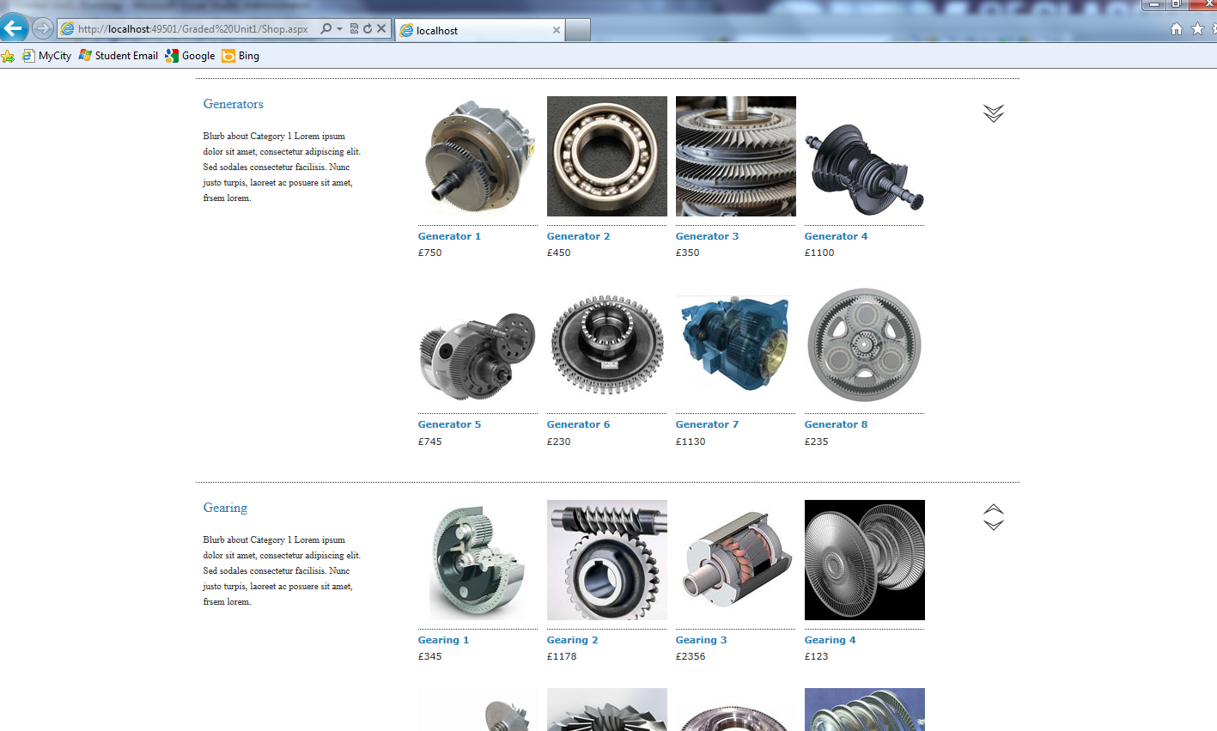

### HTML

<%@ Page Title="" Language="C#" MasterPageFile="~/Lidiflu.Master" AutoEventWireup="true"

CodeFile="Shop.aspx.cs" Inherits="Shop" %>

<asp:Content ID="Content1" ContentPlaceHolderID="head" runat="server">

</asp:Content>

<asp:Content ID="Content2" ContentPlaceHolderID="ContentPlaceHolder1" runat="server">

<script type="text/javascript" src="http://ajax.googleapis.com/ajax/libs/jquery/1/jquery.min.js"></script>

<script type="text/javascript" src="Scripts/jquery.easing.1.3.js"></script>

<script type="text/javascript">

//script for smooth scroll

$(function () {

$('ul.shopul a').bind('click', function (event) {

var $anchor = $(this);

$('html, body').stop().animate({

scrollTop: $($anchor.attr('href')).offset().top

}, 1000, 'easeInOutExpo');

/*

if you don't want to use the easing effects:

$('html, body').stop().animate({

scrollTop: $($anchor.attr('href')).offset().top

}, 1000);

*/

event.preventDefault();

});

});

</script>

<script type="text/javascript">

$(function () {

$('a.scroll').bind('click', function (event) {

var $anchor = $(this);

$('html, body').stop().animate({

scrollTop: $($anchor.attr('href')).offset().top

}, 1000, 'easeInOutExpo');

/*

if you don't want to use the easing effects:

$('html, body').stop().animate({

scrollTop: $($anchor.attr('href')).offset().top

}, 1000);

*/

event.preventDefault();

});

});

</script>

<div id="title" class="container_12">

<h1>

Shop</h1>

</div>

<div id="shopheader" class="container_12">

<div class="shopcategory grid_3">

<div class="shoph2">

Shop by category</div>

<ul class="shopul">

<li><a href="#category1">Generators</a></li>

<li><a href="#category2">Gearing</a></li>

<li><a href="#category3">Turbines</a></li>

<li><a href="#category4">Rotors</a></li>

<li><a href="#category5">R</a>epair Services</li>

</ul>

</div>

<div id="shopimage" class="grid_9">

<img src="Images/wind_farm.jpg" alt="windfamrm" width="700px" height="400px" />

</div>

</div>

<div id="category1" class="container_12">

<div class="shopcategory grid_3">

<div class="shoph2">

Generators</div>

<p class="shoppara">

Blurb about Category 1 Lorem ipsum dolor sit amet, consectetur adipiscing elit.

Sed sodales consectetur facilisis. Nunc justo turpis, laoreet ac posuere sit amet,

frsem lorem.

</p>

</div>

<div class="shoplist grid_8">

<ul id="shopcat1" runat="server">

</ul>

</div>

<div class="shopbutton grid_1 omega">

<a class="scroll" href="#category2">

<img src="img/downarrow.png" /></a></div>

</div>

<div id="category2" class="container_12">

<div class="shopcategory grid_3">

<div class="shoph2">

Gearing</div>

<p class="shoppara">

Blurb about Category 1 Lorem ipsum dolor sit amet, consectetur adipiscing elit.

Sed sodales consectetur facilisis. Nunc justo turpis, laoreet ac posuere sit amet,

frsem lorem.

</p>

</div>

<div class="shoplist grid_8">

<ul id="shopcat2" runat="server">

</ul>

</div>

<div class="shopbutton grid_1">

<a class="scroll" href="#category1">

<img src="img/upparrow1.png" /></a><a class="scroll" href="#category3"><img src="img/downarrow1.png" /></a></div>

</div>

<div id="category3" class="container_12">

<div class="shopcategory grid_3">

<div class="shoph2">

Turbines</div>

<p class="shoppara">

Blurb about Category 1 Lorem ipsum dolor sit amet, consectetur adipiscing elit.

Sed sodales consectetur facilisis. Nunc justo turpis, laoreet ac posuere sit amet,

frsem lorem.

</p>

</div>

<div class="shoplist grid_8">

<ul id="shopcat3" runat="server">

</ul>

</div>

<div class="shopbutton grid_1">

<a class="scroll" href="#category2">

<img src="img/upparrow1.png" /></a><a class="scroll" href="#category4"><img src="img/downarrow1.png" /></a></div>

</div>

<div id="category4" class="container_12">

<div class="shopcategory grid_3">

<div class="shoph2">

Rotors</div>

<p class="shoppara">

Blurb about Category 1 Lorem ipsum dolor sit amet, consectetur adipiscing elit.

Sed sodales consectetur facilisis. Nunc justo turpis, laoreet ac posuere sit amet,

frsem lorem.

</p>

</div>

<div class="shoplist grid_8">

<ul id="shopcat4" runat="server">

</ul>

</div>

<div class="shopbutton grid_1">

<a href="#category3" class="scroll">

<img src="img/upparrow1.png" /></a><a class="scroll" href="#category4"><img src="img/downarrow1.png" /></a></div>

</div>

<div id="category5" class="container_12">

<div class="shopcategory grid_3">

<div class="shoph2">

Engineering Services</div>

<p class="shoppara">

Blurb about Category 1 Lorem ipsum dolor sit amet, consectetur adipiscing elit.

Sed sodales consectetur facilisis. Nunc justo turpis, laoreet ac posuere sit amet,

frsem lorem.

</p>

</div>

<div class="shoplist grid_8">

<ul id="shopcat5" runat="server">

</ul>

</div>

<div class="shopbutton grid_1">

<a href="#category3" class="scroll">

<img src="img/uparrow.png" /></a></div>

</div>

</asp:Content>

### Code Behind

using System;

using System.Collections.Generic;

using System.Linq;

using System.Web;

using System.Web.UI;

using System.Web.UI.WebControls;

using System.Web.UI.HtmlControls;

public partial class Shop : System.Web.UI.Page

{

protected void Page_Load(object sender, EventArgs e)

{

List<Product> p = (List<Product>)Session["Products"];

//for every product in product list create html controls for them to be displayed

foreach (Product product in p)

{

Image img = new Image();

HyperLink link = new HyperLink();

HtmlGenericControl a = new HtmlGenericControl("a");

HtmlGenericControl h3 = new HtmlGenericControl("h3");

HtmlGenericControl para = new HtmlGenericControl("p");

HtmlGenericControl newLi = new HtmlGenericControl("li");

string prodID = Convert.ToString(product.ProdID);

img.ImageUrl = product.ProdImage;

img.ID = prodID;

para.InnerHtml = "£" + Convert.ToString(product.ProdPrice);

h3.InnerHtml = product.ProdName;

link.NavigateUrl = "Products.aspx?id=" + prodID;

link.Controls.Add(img);

link.Controls.Add(h3);

link.Controls.Add(para);

newLi.Controls.Add(link);

//depending on product id, display product control in category sections

if (product.ProdID <= 8)

{

shopcat1.Controls.Add(newLi);

}

else if (product.ProdID > 8 && product.ProdID <= 16)

{

shopcat2.Controls.Add(newLi);

}

else if (product.ProdID > 16 && product.ProdID <= 24)

{

shopcat3.Controls.Add(newLi);

}

else if (product.ProdID > 24 && product.ProdID <= 32)

{

shopcat4.Controls.Add(newLi);

}

else if (product.ProdID > 30)

{

shopcat5.Controls.Add(newLi);

}

}//end foreach

}//end page load event

}//end class

## ShoppingCart.aspx

### Screenshot

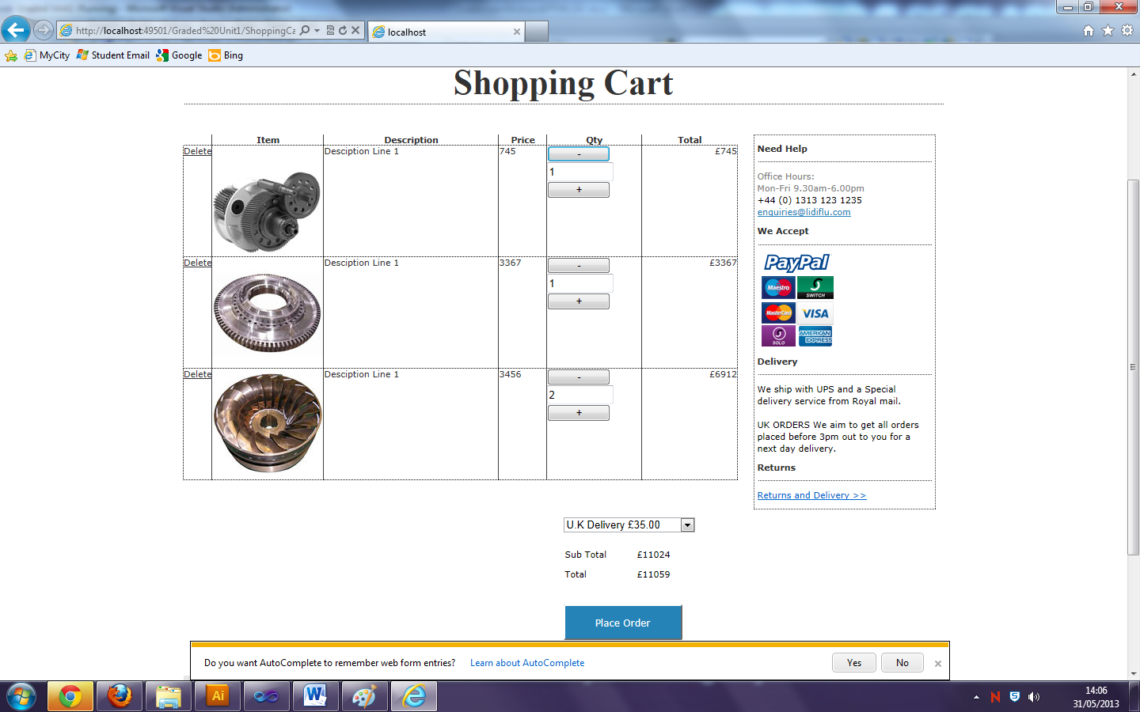

### HTML

<%@ Page Title="" Language="C#" MasterPageFile="~/Lidiflu.Master" AutoEventWireup="true" CodeFile="ShoppingCart.aspx.cs" Inherits="ShoppingCart" %>

<asp:Content ID="Content1" ContentPlaceHolderID="head" runat="server">

</asp:Content>

<asp:Content ID="Content2" ContentPlaceHolderID="ContentPlaceHolder1" runat="server">

<div id="title" class="container_12">

<h1>

Shopping Cart</h1>

</div>

<div id="cartcontainer" runat="server" class="grid_9 alpha">

<asp:GridView ID="GridView1" Width="100%" AutoGenerateColumns="False" OnRowDeleting="GridView1_RowDeleting"

runat="server" RowStyle-VerticalAlign="Top"

AutoGenerateDeleteButton="True" RowStyle-HorizontalAlign="Left"

CellPadding="5" BorderStyle="Dotted" BorderWidth="0px" Font-Size="8pt" Font-Names="Verdana"

ForeColor="#333333" onrowcommand="GridView1_RowCommand">

<HeaderStyle HorizontalAlign="Left" />

<RowStyle BorderStyle="Dotted" BorderWidth="1px" Font-Names="Verdana" Font-Size="11px" />

<Columns>

<asp:TemplateField ControlStyle-Width="140" HeaderText="Item" SortExpression="ProdImage">

<ItemTemplate>

<asp:Image ID="Image1" runat="server" ImageUrl='<%#Bind("ProdImage") %>' />

</ItemTemplate>

<ControlStyle Width="140px"></ControlStyle>

</asp:TemplateField>

<asp:TemplateField ControlStyle-Width="220" HeaderText="Description" SortExpression="Description">

<ItemTemplate>

<asp:Label ID="lblDescript" runat="server" Text='<%#Bind("Description") %>' />

</ItemTemplate>

<ControlStyle Width="220px"></ControlStyle>

</asp:TemplateField>

<asp:TemplateField HeaderText="Price" ControlStyle-Width="60" SortExpression="Price">

<ItemTemplate>

<asp:Label ID="lblPrice" runat="server" Text='<%#Bind("Price") %>' />

</ItemTemplate>

<ControlStyle Width="60px"></ControlStyle>

</asp:TemplateField>

<asp:TemplateField HeaderText="Qty" ControlStyle-Width="80" SortExpression="Price">

<ItemTemplate>

<asp:Button ID="btnMinus" runat="server" CommandName="RemoveItem" CommandArgument="<%# ((GridViewRow) Container).RowIndex %>"

Text="-" />

<asp:Textbox ReadOnly="true" min="0" Width="20px" Height="20px" ID="txtQty" runat="server" Text='<%#Bind("Qty") %>' />

<asp:Button ID="btnPlus" runat="server" CommandName="AddItem" CommandArgument="<%# ((GridViewRow) Container).RowIndex %>"

Text="+" />

</ItemTemplate>

<ControlStyle Width="80px"></ControlStyle>

</asp:TemplateField>

<asp:TemplateField HeaderText="Total" ControlStyle-Width="120" ItemStyle-HorizontalAlign="Right"

SortExpression="Total">

<ItemTemplate>

<asp:Label ID="lblTotal" runat="server" Text='<%#Bind("Total") %>' />

</ItemTemplate>

<ControlStyle Width="120px"></ControlStyle>

<ItemStyle HorizontalAlign="Right"></ItemStyle>

</asp:TemplateField>

</Columns>

</asp:GridView>

<div id="proceed" class="grid_3 prefix_6 alpha">

</br></br>

<asp:DropDownList ID="drpPostage" runat="server" Width="166px" AutoPostBack="True"

OnSelectedIndexChanged="drpPostage_SelectedIndexChanged">

<asp:ListItem Selected="True" Value="35">U.K Delivery £35.00 </asp:ListItem>

<asp:ListItem Value="85">Overseas Delivery £85.00</asp:ListItem>

</asp:DropDownList>

</br></br>

<asp:Table ID="Table1" runat="server" Height="53px" Width="166px">

<asp:TableRow>

<asp:TableCell><p>Sub Total</p></asp:TableCell>

<asp:TableCell ID="cellSub"></asp:TableCell>

</asp:TableRow>

<asp:TableRow>

<asp:TableCell><p>Total</p></asp:TableCell>

<asp:TableCell ID="cellTotal"></asp:TableCell>

</asp:TableRow>

</asp:Table>

<asp:Button ID="btnConfirm" runat="server" CssClass="btnAddToCart" Text="Place Order"

OnClick="btnConfirm_Click" />

</div>

</div>

<div id="cartside" class="grid_3 omega">

<h2>

Need Help</h2>

<p class="grey-text">

Office Hours:</br>Mon-Fri 9.30am-6.00pm</p>

<p>

</p>

<p>

+44 (0) 1313 123 1235</p>

<p>

</p>

<p>

<a style="color: #2583B7" href="mailto:enquiries@lidiflu.com">enquiries@lidiflu.com</a></p>

<h2>

We Accept</h2>

<img src="Images/paymentsmall.png" />

<h2>

Delivery</h2>

<p>

We ship with UPS and a Special delivery service from Royal mail.</p>

<p>

</br></p>

<p>

UK ORDERS We aim to get all orders placed before 3pm out to you for a next day delivery.

</p>

<h2>

Returns</h2>

<p>

<a href="#">Returns and Delivery >> </a>

</p>

</div>

</asp:Content>

### Code Behind

using System;

using System.Collections.Generic;

using System.Linq;

using System.Web;

using System.Web.UI;

using System.Web.UI.WebControls;

public partial class ShoppingCart : System.Web.UI.Page

{

double subTotal = 0;

double total = 0;

double shipping = 00;

protected void Page_Load(object sender, EventArgs e)

{

Customer aCustomer = (Customer)Session["Customer"];

//if its not a post back display orderlines

if (!IsPostBack)

{

var query = from goods in aCustomer.Orders[0].OrderLines

select new

{

Name = goods.Product.ProdName,

Description = goods.Product.ProdDescription,

Price = goods.Product.ProdPrice,

Qty = goods.Quantity,

Total = "£" + Convert.ToString(goods.Quantity * goods.Product.ProdPrice),

ProdImage = goods.Product.ProdImage

};

GridView1.DataSource = query;

GridView1.DataBind();

}

//display totals

subTotal = CartFunctions.getSubTotal(aCustomer);

shipping = Convert.ToDouble(drpPostage.SelectedValue);

cellSub.Text = "£" + Convert.ToString(subTotal);

total = subTotal + shipping;

cellTotal.Text = "£" + total;

}

//check to see if customer has increased order numher

protected void GridView1_RowCommand(object sender, GridViewCommandEventArgs e)

{

if (e.CommandName == "AddItem")

{

// Retrieve the row index stored in the

// CommandArgument property.

int index = Convert.ToInt32(e.CommandArgument);

// Retrieve the row that contains the button

// from the Rows collection.

GridViewRow row = GridView1.Rows[index];

// Add code here to add the item to the shopping cart

Customer aCustomer = (Customer)Session["Customer"];

aCustomer.Orders[0].OrderLines[index].Quantity += 1;

//display orderlines

var query = from goods in aCustomer.Orders[0].OrderLines

select new

{

Name = goods.Product.ProdName,

Description = goods.Product.ProdDescription,

Price = goods.Product.ProdPrice,

Qty = goods.Quantity,

Total = "£" + Convert.ToString(goods.Quantity * goods.Product.ProdPrice),

ProdImage = goods.Product.ProdImage

};

subTotal = CartFunctions.getSubTotal(aCustomer);

cellSub.Text = "£" + Convert.ToString(subTotal);

total = subTotal + shipping;

cellTotal.Text = "£" + total;

GridView1.DataSource = query;

GridView1.DataBind();

Session["Customer"] = aCustomer;

}

//check to see if customer has decreased order numher

if (e.CommandName == "RemoveItem")

{

// Retrieve the row index stored in the

// CommandArgument property.

int index = Convert.ToInt32(e.CommandArgument);

// Retrieve the row that contains the button

// from the Rows collection.

GridViewRow row = GridView1.Rows[index];

Customer aCustomer = (Customer)Session["Customer"];

aCustomer.Orders[0].OrderLines[index].Quantity -= 1;

//display orderlines

if (aCustomer.Orders[0].OrderLines[index].Quantity == 0)

{

aCustomer = CartFunctions.removeItem(aCustomer, index);

if (aCustomer.Orders[0].OrderLines.Count == 0)

{

HyperLink continueShop = new HyperLink();

continueShop.NavigateUrl = "Shop.aspx";

continueShop.Text = "Back to the Shop";

cartcontainer.InnerHtml = "You have nothing in your cart" + " ";

cartcontainer.Controls.Add(continueShop);

}

}

//display orderlines

var query = from goods in aCustomer.Orders[0].OrderLines

select new

{

Name = goods.Product.ProdName,

Description = goods.Product.ProdDescription,

Price = "£" + goods.Product.ProdPrice,

Qty = goods.Quantity,

Total = "£" + Convert.ToString(goods.Quantity * goods.Product.ProdPrice),

ProdImage = goods.Product.ProdImage

};

subTotal = CartFunctions.getSubTotal(aCustomer);

cellSub.Text = "£" + Convert.ToString(subTotal);

total = subTotal + shipping;

cellTotal.Text = "£" + total;

GridView1.DataSource = query;

GridView1.DataBind();

Session["Customer"] = aCustomer;

}

}

//if row is deleted remove orderline

protected void GridView1_RowDeleting(Object sender, GridViewDeleteEventArgs e)

{

Customer aCustomer = (Customer)Session["Customer"];

int index = e.RowIndex;

aCustomer = CartFunctions.removeItem(aCustomer, index);

if (aCustomer.Orders[0].OrderLines.Count == 0)

{

HyperLink continueShop = new HyperLink();

continueShop.NavigateUrl = "Shop.aspx";

continueShop.Text = "Back to the Shop";

cartcontainer.InnerHtml = "You have nothing in your cart" + " ";

cartcontainer.Controls.Add(continueShop);

}

var query = from goods in aCustomer.Orders[0].OrderLines

select new

{

Name = goods.Product.ProdName,

Description = goods.Product.ProdDescription,

Price = goods.Product.ProdPrice,

Qty = goods.Quantity,

Total = "£" + Convert.ToString(goods.Quantity * goods.Product.ProdPrice),

ProdImage = goods.Product.ProdImage

};

subTotal = CartFunctions.getSubTotal(aCustomer);

cellSub.Text = "£" + Convert.ToString(subTotal);

GridView1.DataSource = query;

GridView1.DataBind();

Session["Customer"] = aCustomer;

}

//if change postage and packaging cost on change of drop down

protected void drpPostage_SelectedIndexChanged(object sender, EventArgs e)

{

total = subTotal + Convert.ToDouble(drpPostage.SelectedValue);

cellTotal.Text = "£" + Convert.ToString(total);

}

//calls paypal API

protected void btnConfirm_Click(object sender, EventArgs e)

{

Customer aCustomer = (Customer)Session["Customer"];

NVPAPICaller payPalCaller = new NVPAPICaller();

string retMsg = "";

string token = "";

string amt = "";

string shippingAmt = "";

string subAmt = "";

shippingAmt = shipping.ToString();

subAmt = subTotal.ToString();

amt = total.ToString();

Session["payment_amt"] = total;

bool ret = payPalCaller.ShortcutExpressCheckout(subAmt, shippingAmt, amt, ref token, ref retMsg, aCustomer);

if (ret)

{

Session["token"] = token;

Response.Redirect(retMsg);

}

else

{

Response.Redirect("CheckoutError.aspx?" + retMsg);

}

}

}